**Step by Step Guide for execution process**

1.Open the Ngrok link

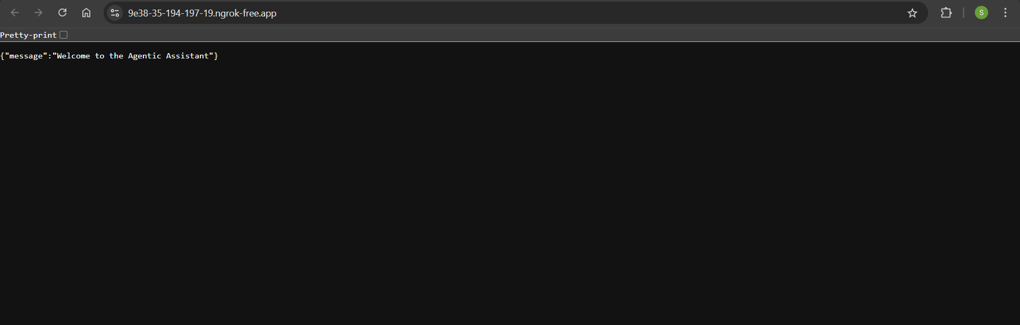

2.Add “/docs” in the url

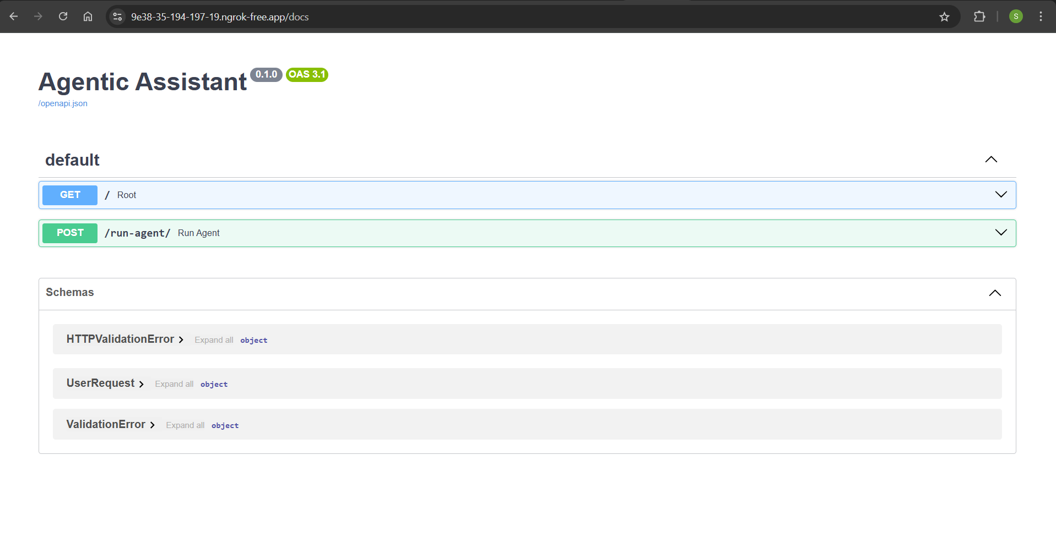

3.Expand POST and click on try it out

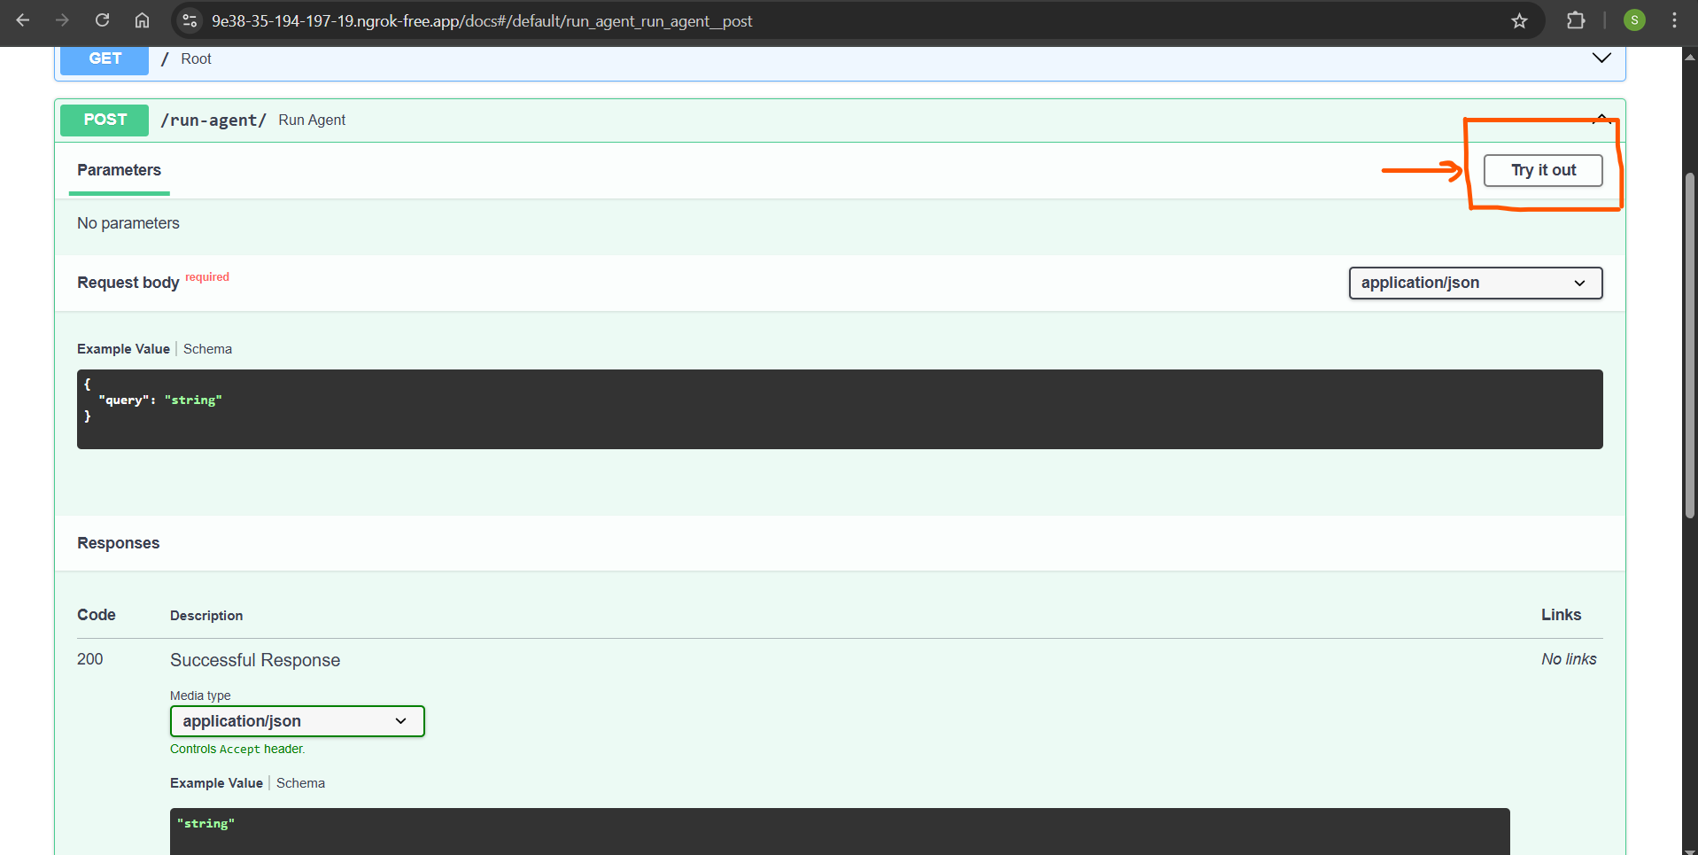

4.Add the query and click on execute

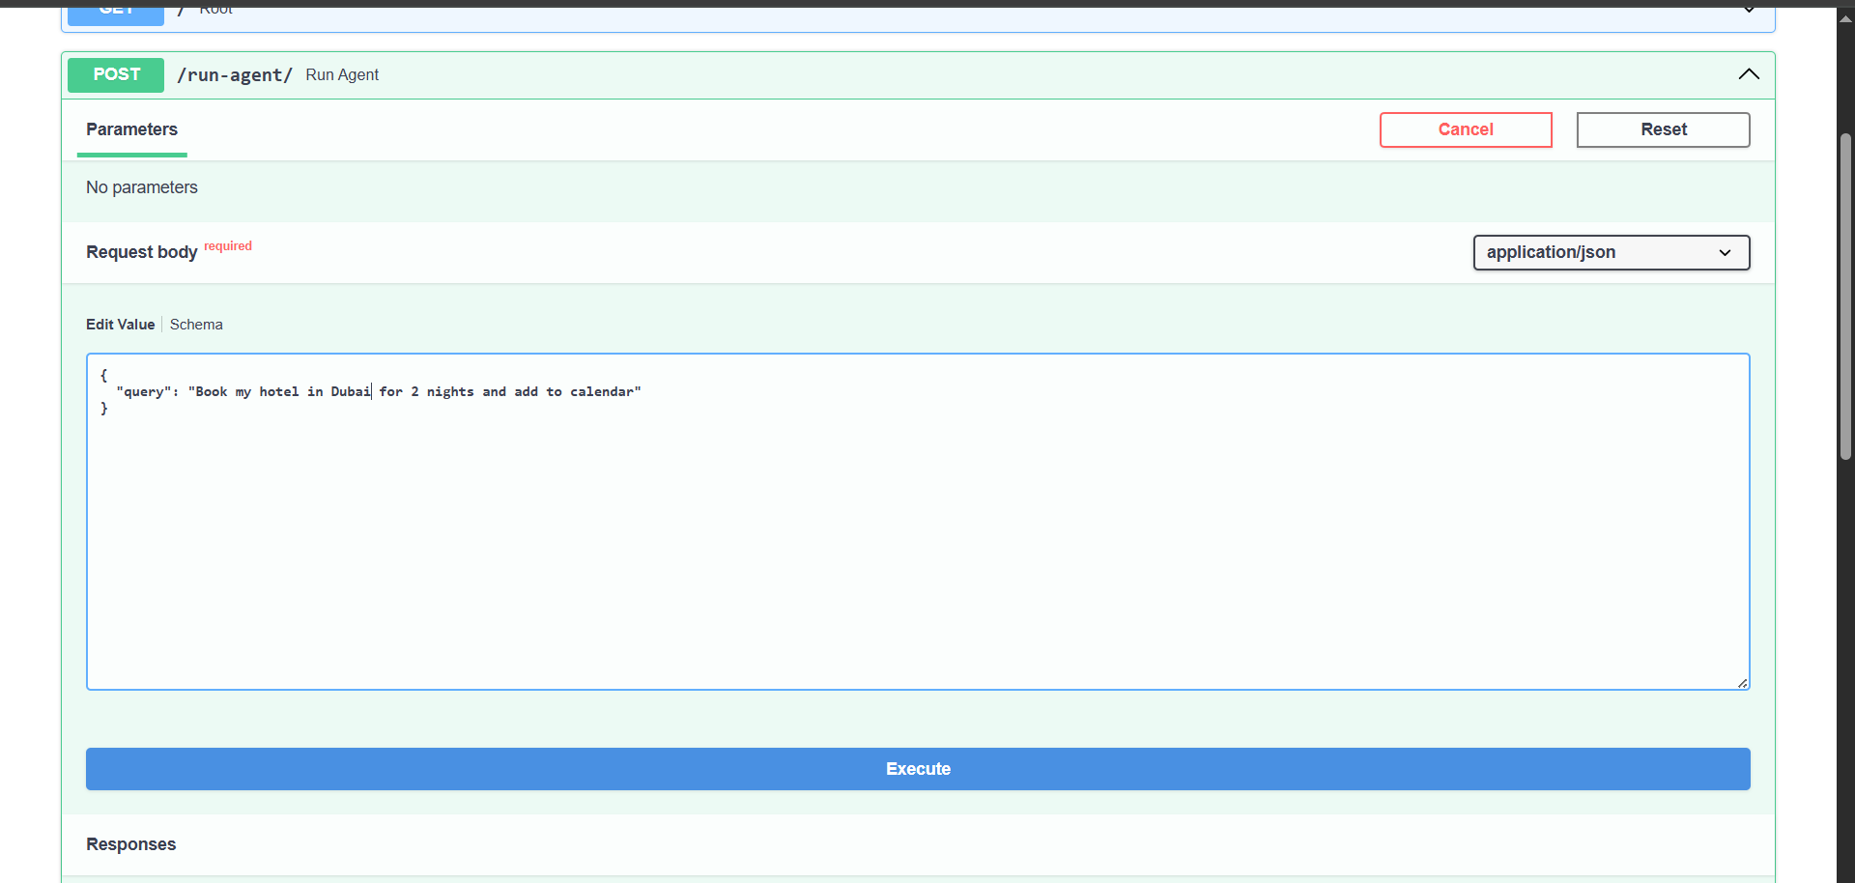

5.View Response:

